Metric ID: 6.2.2

ERP link
Admin Login
http://erp23.goenkacollege.org/GraduationERP/Admin/LoginPage.aspx
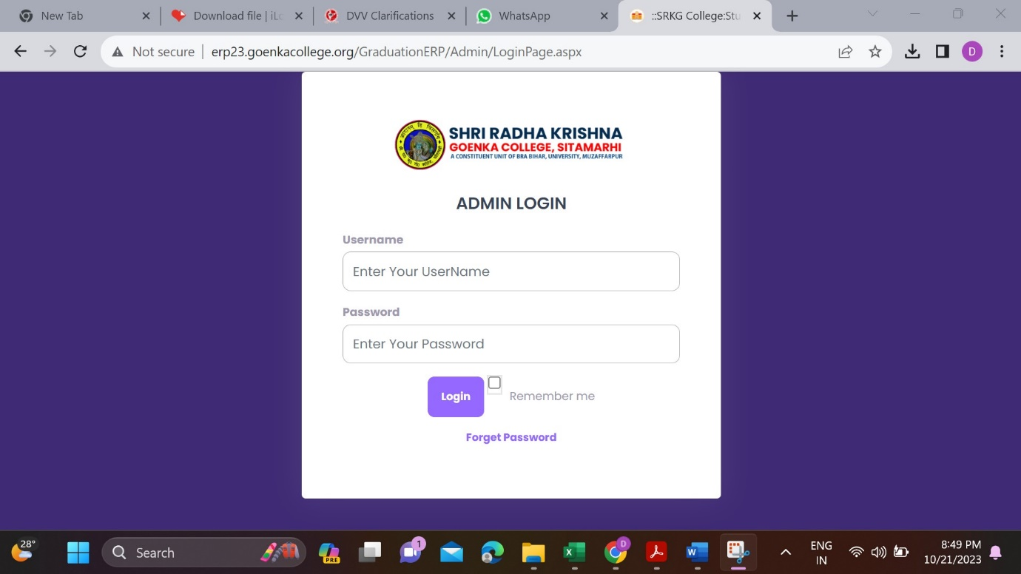

Admin Dashboard
http://erp23.goenkacollege.org/GraduationERP/Admin/admindashboard.aspx

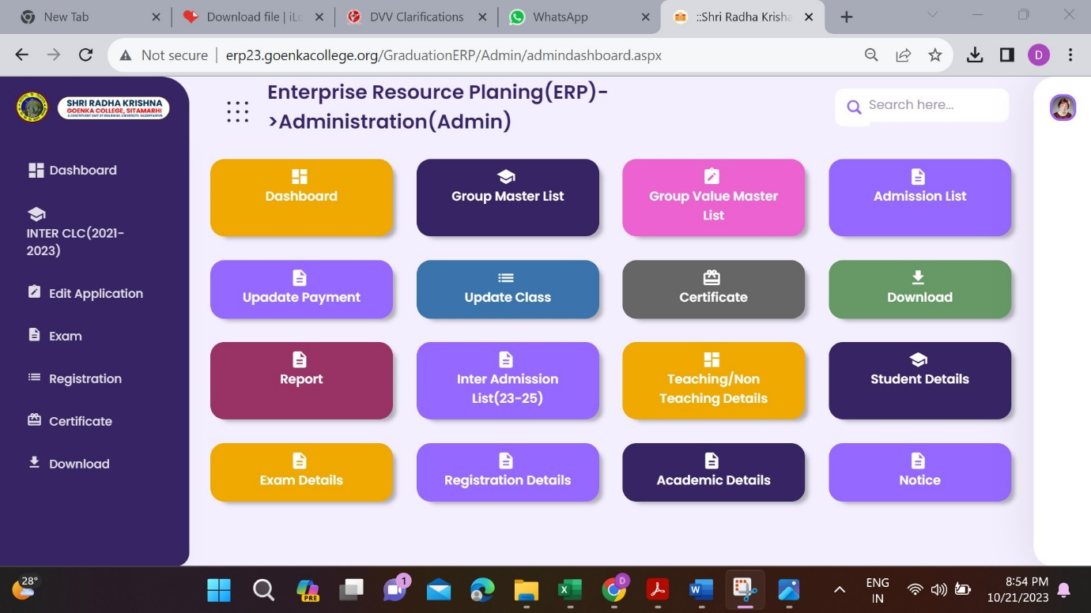

Student Login
http://erp23.goenkacollege.org/GraduationERP/Student/loginPage.aspx
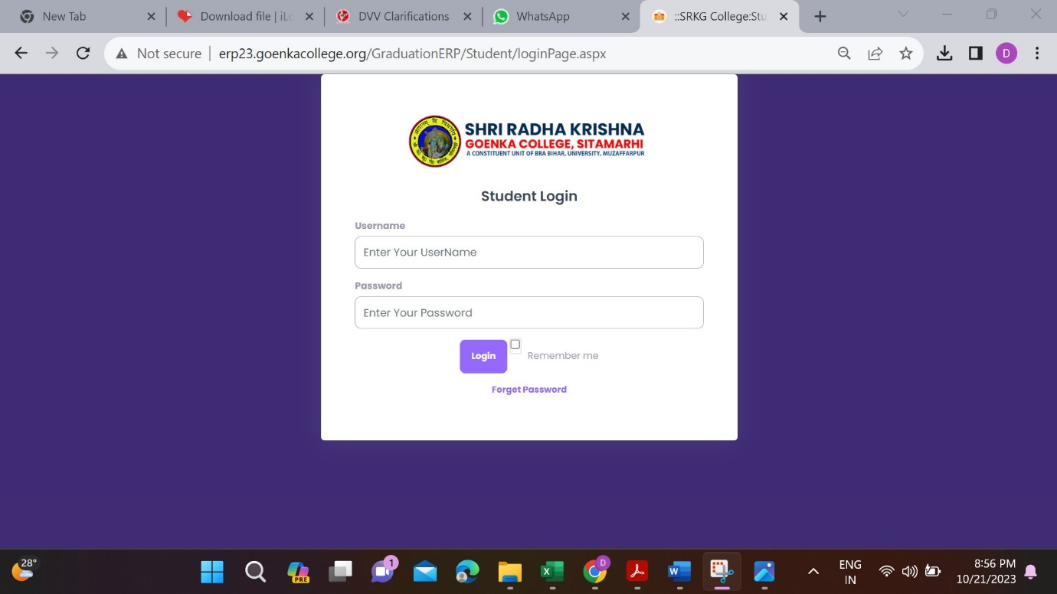

Student Dashboard
http://erp23.goenkacollege.org/GraduationERP/Student/GrstudentDashboard.aspx
